Experiment-9
Home.js
import React from 'react';
function Home(){
return(
<div>
<h1> Welcome to Home Page</h1>
<p> This is the Home Component</p>
</div>
);
}
export default Home;
Contact.js
import React from 'react';
function Contact(){
return(
<div>
<h1> Welcome to Contact Page</h1>
<p> This is the Contact Component</p>
</div>
);
}
export default Contact;
About.js
import React from 'react';
function About(){
return(
<div>
<h1> Welcome to About Page</h1>
<p> This is the About Component</p>
</div>
);
}
export default About;
App.js
import React from "react";
import { BrowserRouter, Routes, Route, Link } from "react-router-dom";
import Home from "./Home";
import About from "./About";
import Contact from "./Contact";
function App() {
return (
<BrowserRouter>
<nav>
<Link to="/">Home</Link> |
<Link to="/about">About</Link> |
<Link to="/contact">Contact</Link>
</nav>
<Routes>
<Route path="/" element={<Home />} />
<Route path="/about" element={<About />} />
<Route path="/contact" element={<Contact />} />
</Routes>
</BrowserRouter>
);
}
export default App;

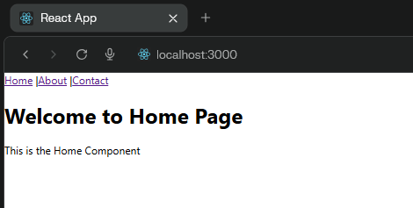
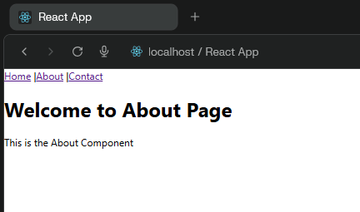

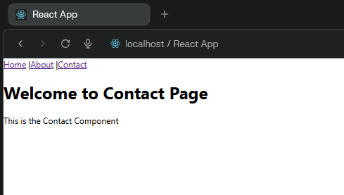

B)
Program:
import React,{ useState } from "react";
function UpdateScreen(){
const [count, setCount] = useState(0);
const updatecount=()=>{
setCount(count+1);
};
return(
<div>
<h1>Count value {count}</h1>
<button onClick = {updatecount}>Increase Count
</button>

</div>
);
}
export default UpdateScreen;
Output:
